Day -3
1.Understand IP addressing and check system IP using ip a or ifconfig.
Command : ip a
It show the details of the network and ip address
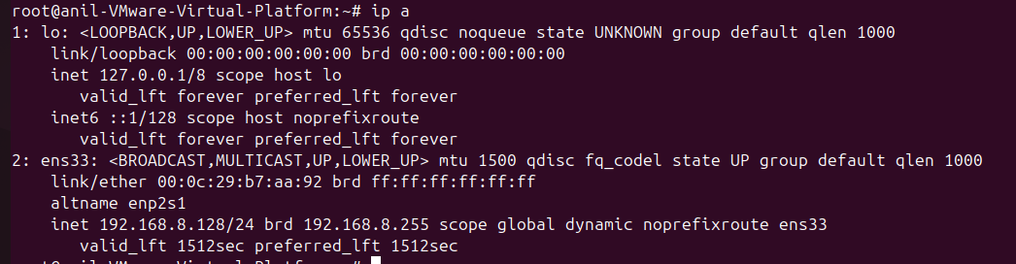

2.Test connectivity using ping to public servers like Google DNS.
Command: ping google.com
Ping command check the network connectivity and it transmits the data packets
If server is up then it show the packet transfers
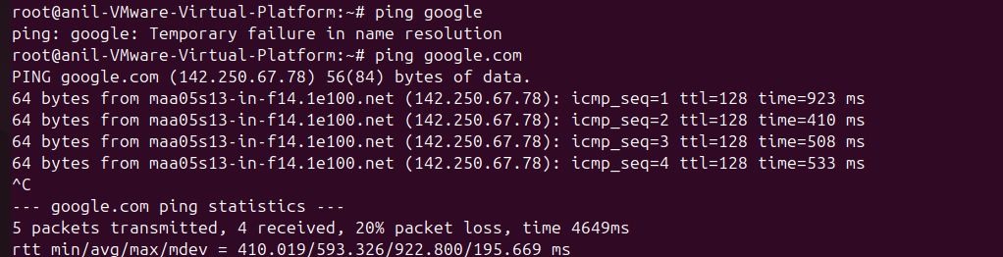

3.Use netstat or ss to inspect open ports and services.
Command: netstat
This is used to show the listening ports in tcp and udp
It show the ip address and processed and also tcp/udp
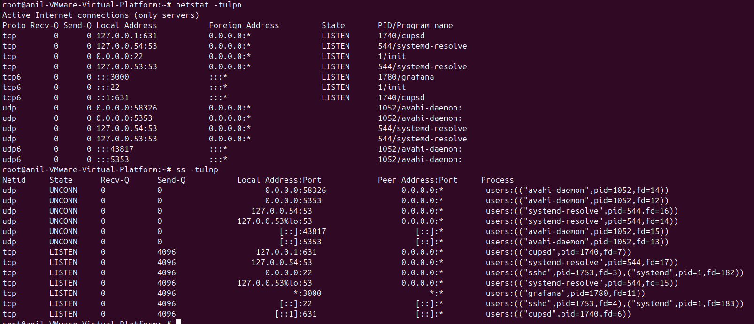
4.Learn DNS resolution using nslookup and dig.
Command: nslookup google.com
It shows ipaddress ipv4 and v6 of the server
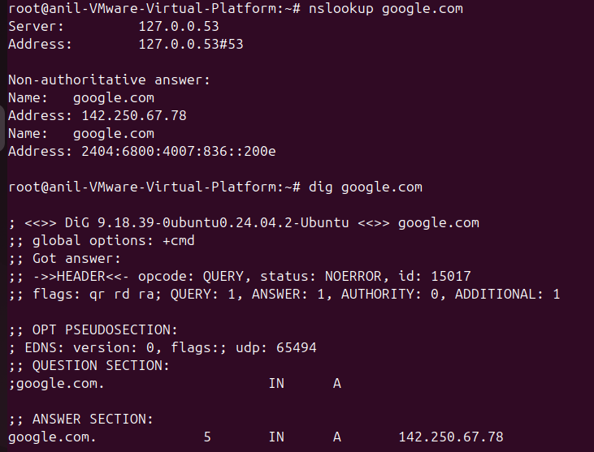
5.Trace network path using traceroute.
Command: traceroute google.com
Trace the network path that packets take from your system to a destination
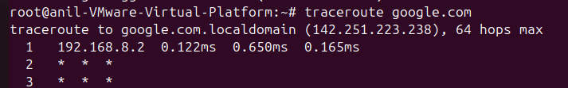

6.Simulate network failure by disabling interfaces.
After disable the network with the command nmcli networking off
We check with ping command then it is not working
After network is on then ping is working
